Project: Safe Cherries
Difficulty: Level 1

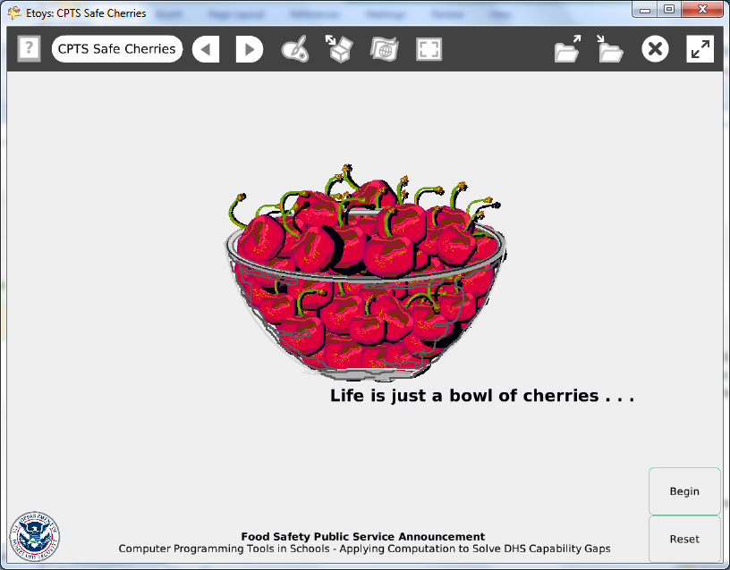

Time: Two 45 minute labs

Challenge: Design a public service announcement about food safety. Use screen capture software to make a video suitable for YouTube and your local TV stations.

Programming:
Basic script tiles for x and y location, heading, a declared variable and four conditional statements
Scripting commands control when scripts run or pause

Things you’ll need to know:
Scripting Tiles are commands that control when other scripts run. Click and hold down on the Viewer’s basic category to open a menu; select Scripting.
Quick Guides
- Paint Tools/ All
- Halo Handles/All
- Script Tiles: X and Y tiles, Exact Location, Heading, Tests Category, Scripting, Hide and Show
- Supplies: Text
- Menus: Normal Ticking, Viewer Icons Set (information about declaring a variable)

Things to think about:
- When should the scripts run? Why is one set to “Normal”?
- What would be a better symbol for food safety public service announcement?

Extensions:
- Can you make the scripts start when the project opens?

NETS for Students:
http://www.iste.org/standards/nets-for-students/nets-student-standards-2007.aspx
1. Creativity and Innovation: a, b, c
2. Communication and Collaboration: a, b, c
3. Research and Information Fluency: a, b, c
4. Critical Thinking, Problem Solving, and Decision Making: a, b, c
5. Digital Citizenship: a, b
6. Technology Operations and Concepts: a, b, c, d

CSTA:
CSTA Level II: Objectives and Outline
http://csta.acm.org/Curriculum/sub/CurrFiles/L2-Objectives-and-Outlines.pdf
Level II objectives for middle school students are furthered through studying a programming language well enough that the student is proficient with it. Whether the language is Etoys, StarLogo TNG, or Scratch, it is the ability to use the language to express ideas that is valuable. A student skillful enough to use any programming language to express ideas, solve problems, model behaviors, simulate data, or to educate or entertain is an entitled person in today’s society. Topics of particular note are:
Topic 2: Problem Solving
Topic 6: Connections between Mathematics and Computer Science
Topic 11: Programming Languages
Topic 13: Multimedia

Common Core Standards Mathematics:
http://www.corestandards.org/the-standards/mathematics
6. NS.6, 6.RP.3, 6.EE.5
7. EE.3
8. F.1, 8.F.4, 8.G.1

Teacher Notes:
Show the Etoys project and then the screen capture video of it.

Local TV stations are required to devote a percentage of their broadcast time to public service announcements. Contact your local station for more information about their policies. Projects related to current events and local topics may strengthen your chances of a TV station broadcasting some of these projects.

A team of students could curate and produce these videos.

Materials: Check news media for local current events regarding food safety.
www.dhs.gov The U.S. Department of Homeland Security includes informational links about food safety and supply infrastructure. For example: http://blog.dhs.gov/2010/11/thanksgiving-safety-tips-from-us-fire.html

www.fda.gov The U.S. Food and Drug Administration web site lists recalls and safety alerts
Comments: The use of a declared variable to control when a script will start or stop takes time to understand how it will work. Experiment with the elapsed time to achieve the effect the students wants. Provide time for experiments.

Objects - Scripts – Decisions
Painting the scene e.g. the bowl filled with cherries takes time in class. Students could plan their topic message and sketch at home.
The topic and text of the warning message takes research and thought.
One cherry has a script.

Example Scripts:
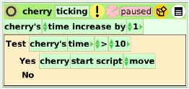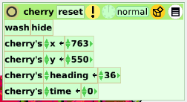
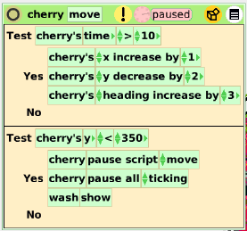
Student Notes:
None provided.

